This is an updated document for Pattern Recognition.
The original document was sent March 11 was labelled Document-Assignment1b-Nermeen-PatternRegonition-PlusPlots. ONLY THE TABLE FOR ACCURACIES AND PLOT OF ACCURACIES WERE CHANGED
Please also check the original submission files as they have more code and content.
The Updated section of this document will be HIGHLIGHTED IN YELLOW. The UNHIGHLTED SECTION was already in the original document submission.
To find the UPDATED AREA use CTRL+F and type“UPDATED AREA”
The original assignment was submitted by blackboard and to Dr. Mohamed Moustafa's email March 11. The updated code is multixb.m while the original code was multix.m (undocumented) and multix2.m(same as multix but documented). The changes in the code are included for your convenience.
The content of the unhighlighted section of the assignment was already available in the older document.
a)
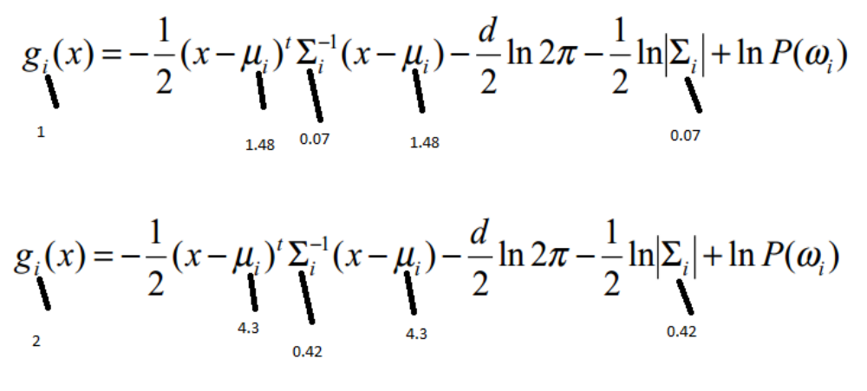
Equation of threshold: g1(x) = g2(x). The equation in part a was done by posterior probability rather than substituting the g in the above equations.
By getting p(x) from the likelihood and calculating the posterior as being liklihoold *prior/evidence but using the gaussian equations.
Feature (1) + threshold

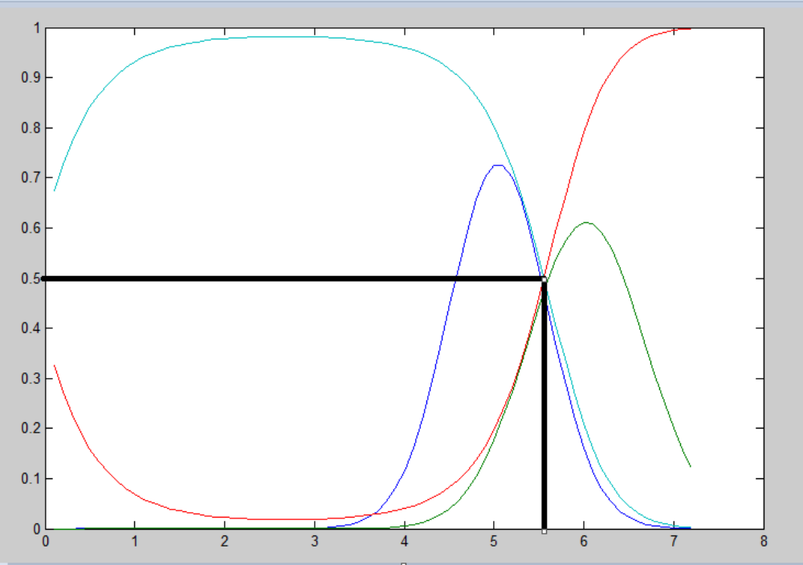
Feature 2
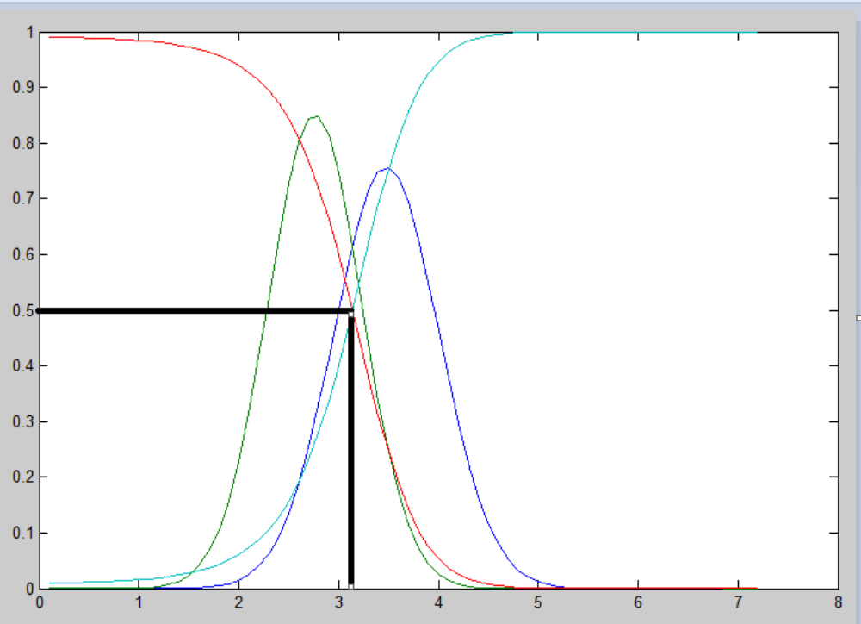
Feature 3
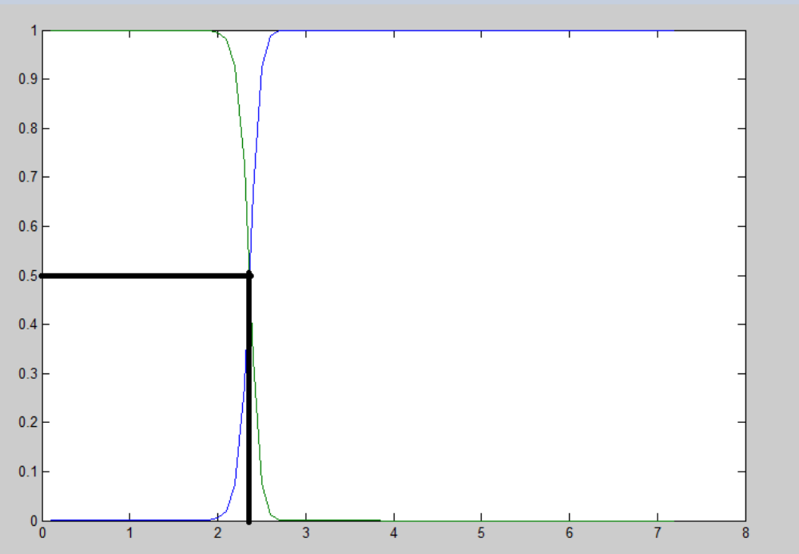
feature 4
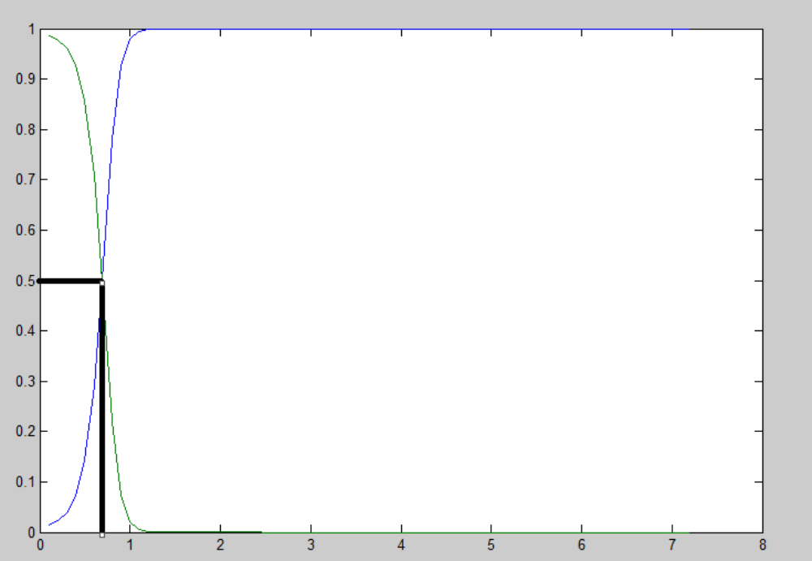
%%%%%%%%%%%%%%%%%%%%%%%%%%%%%%%%%%%%%%%%%%%%%%%%%%%%
b) The classification accuracy using the best designated classes which are both features 3 and 4 are 1.
%%%%%%%%%%%%%%%%%%%%%%%%%%%%%%%%%%%%%%%%%%%%%%%%%%%%
c) The threshold in the first assignment using naive bayes was not as graceful at the 0.5 threshold as the second assignment however the calculation of the threshold was differnt which was the first value at whic the thresholds intersect or change values, and not the interstection with 0.5 using the naive bayes. So the accuracies for feature 3 is exactly the same as 1.
The threshold of feature 3 using Bayes(the first image) compared to Gaussian (second image)
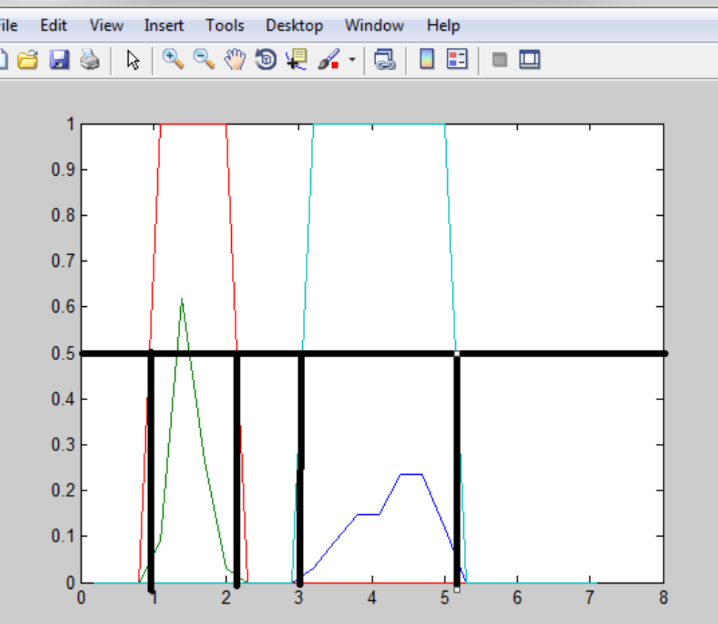
The classification accuracy of both is 1. So there is no change in accuracy when using the best class. If the classification was done using 0.5 to determine the boundary rather than the intersection of the two posterior probabilities with naive bayes the accuracy might have been slightly lower in assignment 1.
%%%%%%%%%%%%%%%%%%%%%%%%%%%%%%%%%%%%%%%%%%%%%%%
d) Two use mutivariate gaussian the following equations were used.
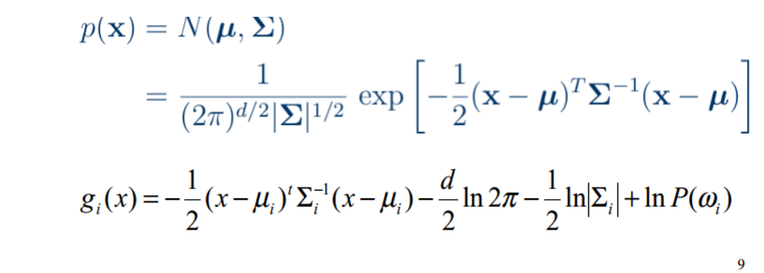
(The covariance matrix was calculated by making a column vector of x-mu for each feature. Multiplying it by the transpose then summing the features and finally dividing by n.)
g1x = setosa
g2x = versicolor
For two features the equation used The equation is as follows:
g1x12 = -1/2 *xmu12t * inv(xmu12co)* xmu12 - log(2 *3.1416) - 0.5 *log(det(xmu12co));
g2x12 = -1/2 *xmuv12t * inv(xmuv12co)* xmuv12 - log(2 *3.1416) - 0.5 * log(det(xmuv12co));
Where xmu12 = [xt(i)-Ex1;xt(j)-Ex2]; Ex1 and Ex2 are the means
xmu12t is the transpose
xmuv12 = the same but for versicolor
xmu12co = a square by square covariance matrix calculated by sum of
[x-mu]*[x-mu]' where the dash is the transpose. (see code) (setosa) (covariance)
xmuv12co = The same as xmu12co but for class versicolor
Ex = [av(f1),av(f2)]; average of the points of each feature, where the average is calculating by taking the sum of all points pertaining to that specific value or class (setosa). In the above example the E(x)
is incorporated in the Ex, with each feature subtracted from x. (This is the same for the equations below)
Exv = is the same as Ex but for class two versicolor
g is 2d
~~~~~~~~~~~~~~~
For three features the equation used The equation is as follows:
g1x123 = -1/2 *xmu123t * inv(xmu123co)* xmu123 - 1.5*log(2 *3.1416) - 0.5 *log(det(xmu123co));
g2x123 = -1/2 *xmuv123t * inv(xmuv123co)* xmuv123 - 1.5*log(2 *3.1416) - 0.5 * log(det(xmuv123co));
Where xmu123 = [xt(i)-Ex1;xt(j)-Ex2;xt(k)-Ex3]; Ex1,Ex2,Ex3 are the means. xmu123 is calculated using different values of x from 0 to 8 and not the dataset values, as they are random values. The same applies for xmu12 in the previous equation and the following equations
xmu123co = a cube covariance matrix calculated by sumof
x-mu.x-mu' (setosa) (covariance) (see codes for specifics)
xmuv123co = The same as xmu123co but for class versicolor
Ex = [av(f1),av(f2);av(f3)]; average of the points of each feature, where the average is calculating by taking the sum of all points pertaining to that specific value or class (setosa)
Exv = is the same as Ex but for class two versicolor
g is 3d
%%%%%%%
For four features the equation used The equation is as follows:
g1x1234 = -1/2 *xmu1234t * inv(xmu1234co)* xmu1234 - 2*log(2 *3.1416) - 0.5 *log(det(xmu12co));
g2x1234 = -1/2 *xmuv1234t * inv(xmuv1234co)* xmuv1234 - 2*log(2 *3.1416) - 0.5 * log(det(xmuv1234co));
Where xmu1234 = [xt(i)-Ex1;xt(j)-Ex2;xt(k)-Ex3;xt(l)-Ex4]; Ex1,Ex2,Ex3,Ex4 are the means
xmuv1234 is the same butfor class versicolor
xmu1234co = a 4d covariance matrix calculated by summing the x-u for each feature after multiplication (setosa) (covariance)
xmuv1234co = The same as xmu12co but for class versicolor
Ex = [av(f1),av(f2);av(f3);av(f4)]; average of the points of each feature, where the average is calculating by taking the sum of all points pertaining to that specific value or class (setosa)
Exv = is the same as Ex but for class two versicolor
g is 4d
%Please refer to code for accurate representations.
~~~~~~~~~~~`
Updated Area
Accuracy attained from single features, feature pairs, using three features and four features respectively, as shown in the table below. Acc is short for accuracy. f1,f2,f3, and f4 are the four features that describe the iris flower respectively.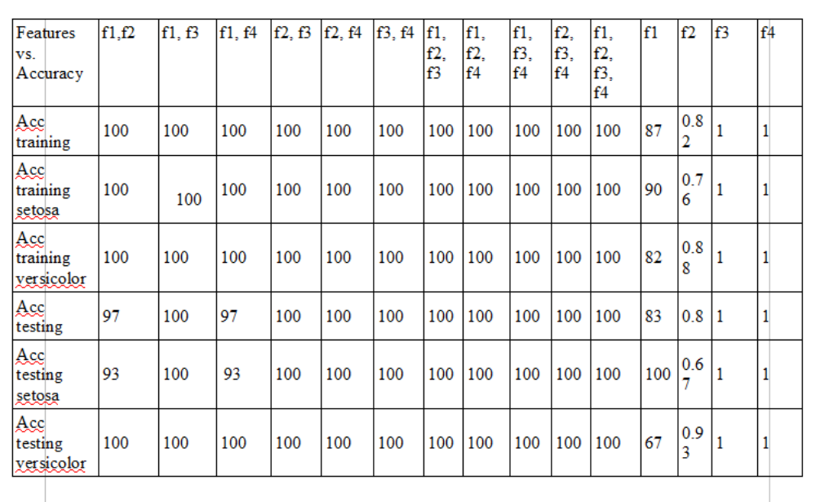
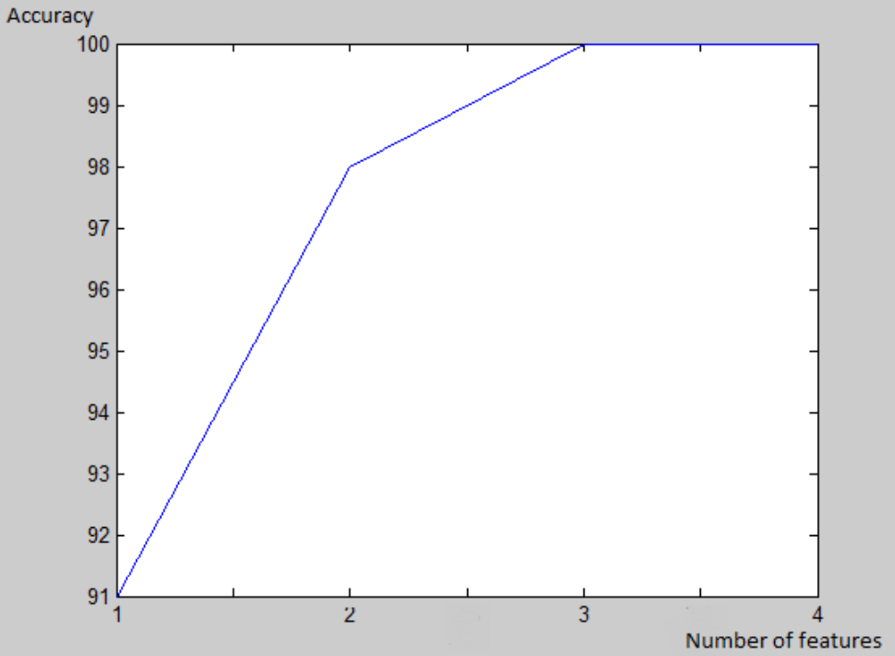
(The values were derived from the testing set)
Overall accuracy of 1 feature = 91
Overall accuracy of 2 features = 98
Overall accuracy of 3 features = 100
Overall accuracy of 4 features = 100
Explanation of UPDATED Results and CODE:
In the original code submissions multix and multix2 there was just a mistake in the for loop when checking the classifier against training and testing set for accuracy
Below is an example when checking three features against te training/stesting set. The for loop was as follows: (Area that caused the error is highlighted in gray)
Original Code in multix(undocumented code) and multix2(documented) that had the mistake
for i=1:Rtr
for j=1:Rtr
for k=1:Rtr
if g1x134m(trainf1(i,1)*10,trainf3(j,1)*10,trainf4(k,1)*10)> g2x134m(trainf1(i,1)*10,trainf3(j,1)*10,trainf4(k,1)*10)
class = 'Iris-setosa';
if strcmp(class,char(trainc(i,1)))
true = true+1;
trues = trues+1;
else
false = false+1;
falses = falses+1;
end

else
class = 'Iris-versicolor';
if strcmp(class,char(trainc(i,1)))
true = true+1;
truev = truev+1;
This caused 50 percent accuracy since i and j were not the same parameters especially when trainc(i,1) which was the class label and trainf3(j,1) which was the class feature being tested, mismatched. The training set also became 3 times the size it was before at least.
To fix this all I did was make a single for loop, and assign values of i instead of j and k, to train f3 and trainf4. (Repeated for training/testing of other features)

Udated version of the code in multixb (Updated Code that fixed results) The areas fixed are highlighted with yellow were the ones changed to achieve the updated results.
for i=1:Rtr
%for j=1:Rtr %commented out
%for k=1:Rtr %commented out
if g1x134m(trainf1(i,1)*10,trainf3(i,1)*10,trainf4(i,1)*10)> g2x134m(trainf1(i,1)*10,trainf3(i,1)*10,trainf4(i,1)*10)
class = 'Iris-setosa';
if strcmp(class,char(trainc(i,1)))
true = true+1;
trues = trues+1;
else
false = false+1;
falses = falses+1;
end

else
class = 'Iris-versicolor'
This caused accuracy to be 100% as the training class is now being matched correctly against training features.
----End of Updated Area!
%%%%%%% 3D plots genearted for the gaussian function and the g functions when using two feature to classify features versicolor and serosa.%%%%%%%
Features 1 and 2 (Petal length and Petal width)
Gaussian function
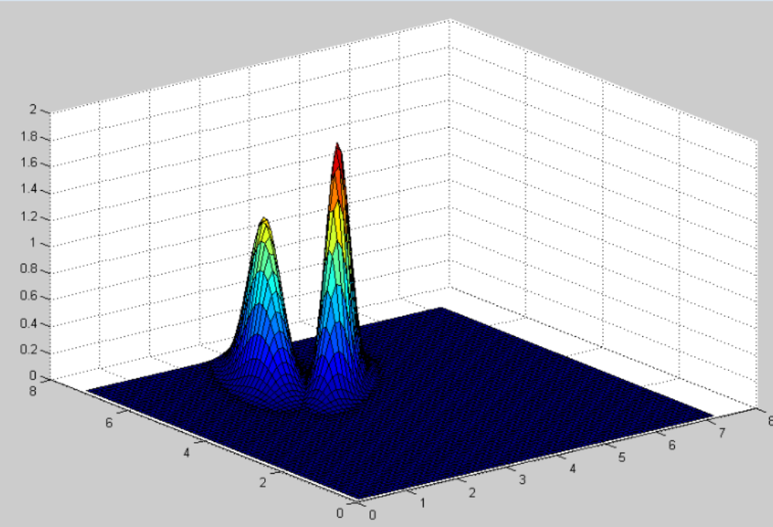
G functions
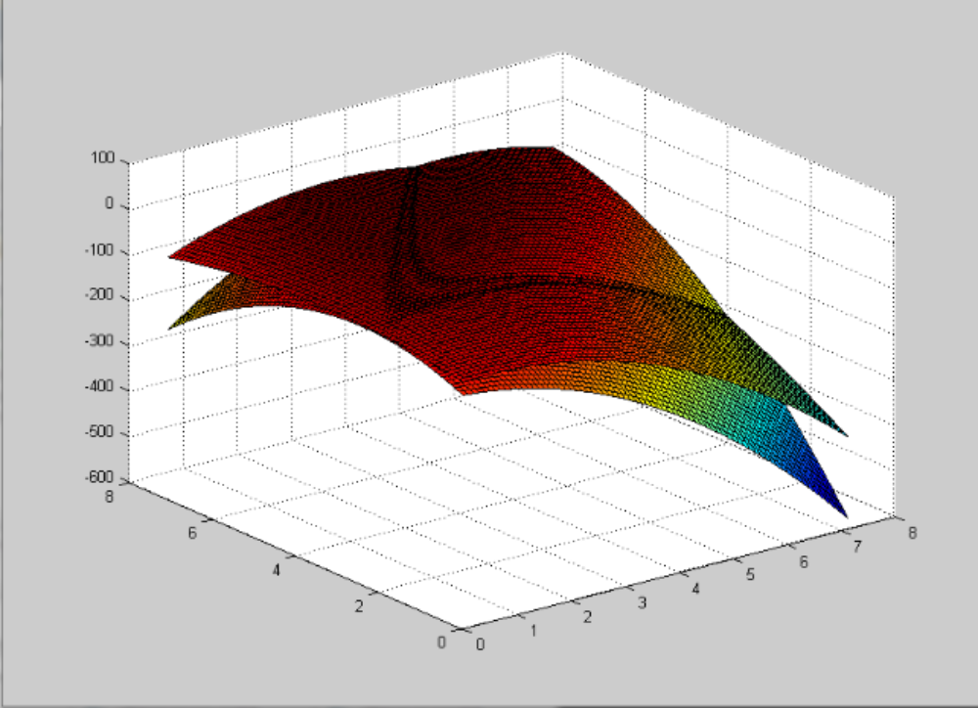

Features 2 and 3: petal width, sepal length
Gaussian function (likelihood)
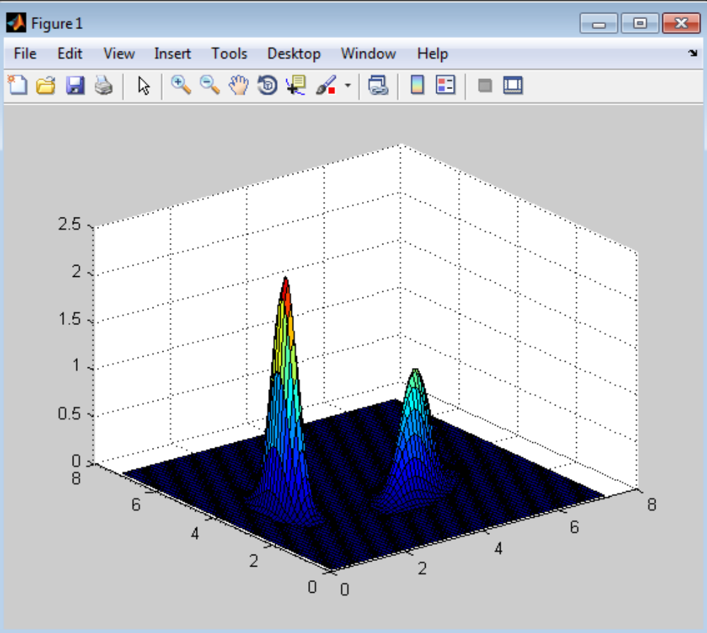
g function (boundary function)
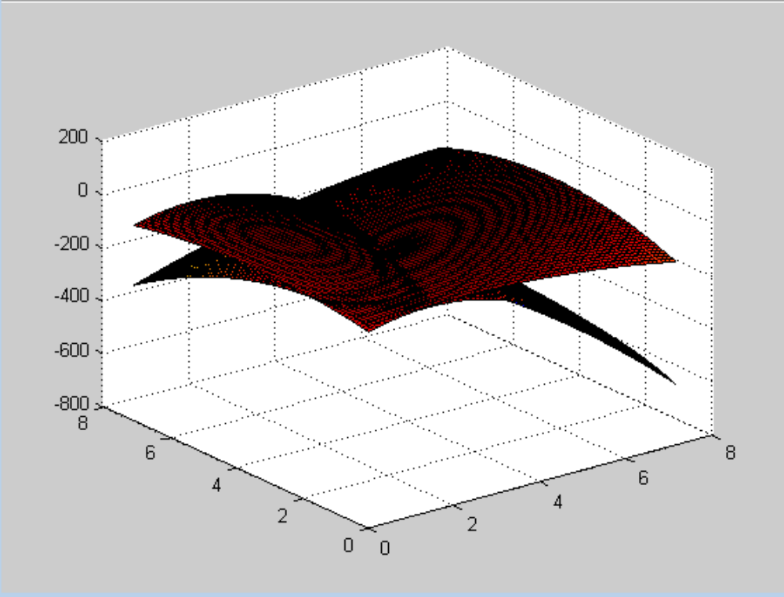
Features 2 and 4 (Petal width, and Sepal width)
Gaussian function
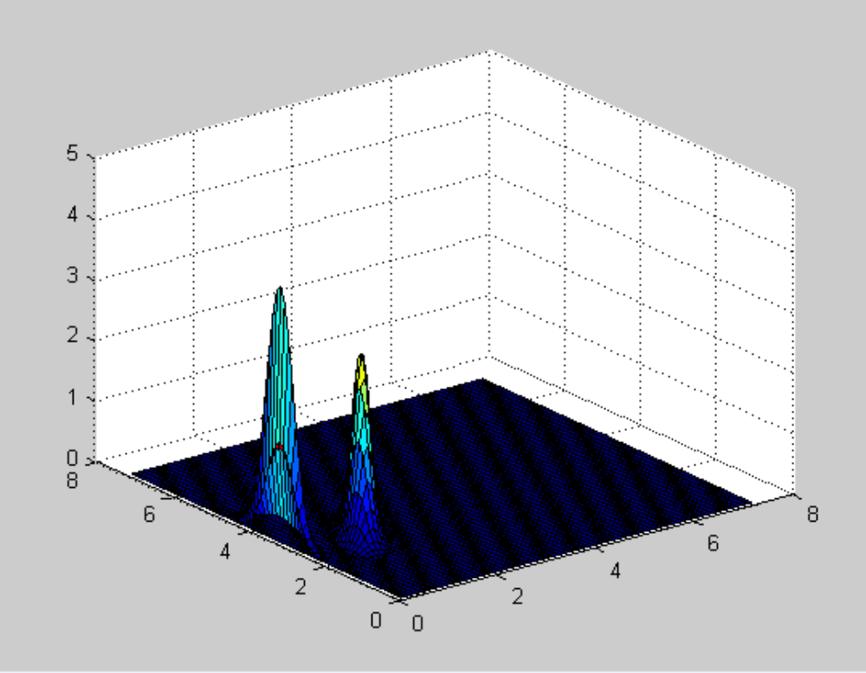
g border functions
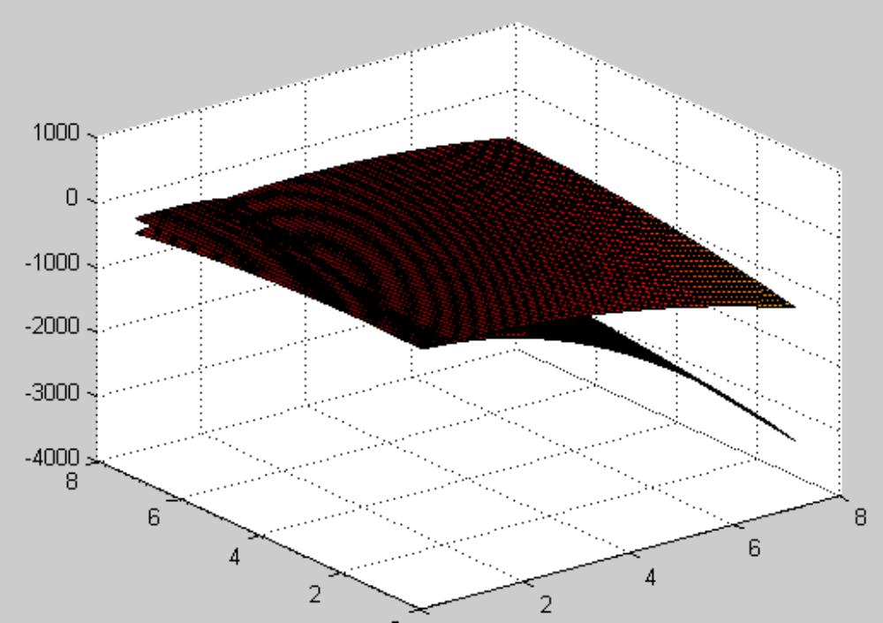
~~~~~
Features 3 and 4: (sepal length,width)
gaussian
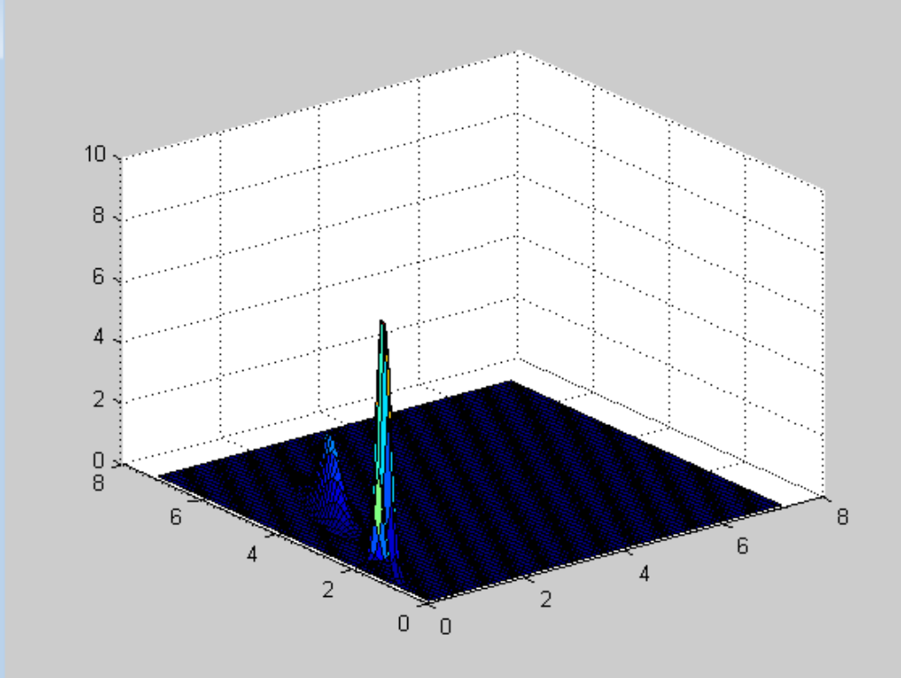
g border functions
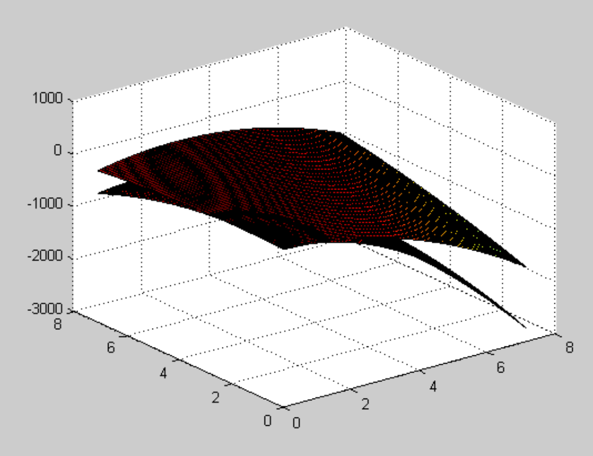
~~~~~
Features 1 and 3 (Petal legnth, sepal Length)
Gaussian
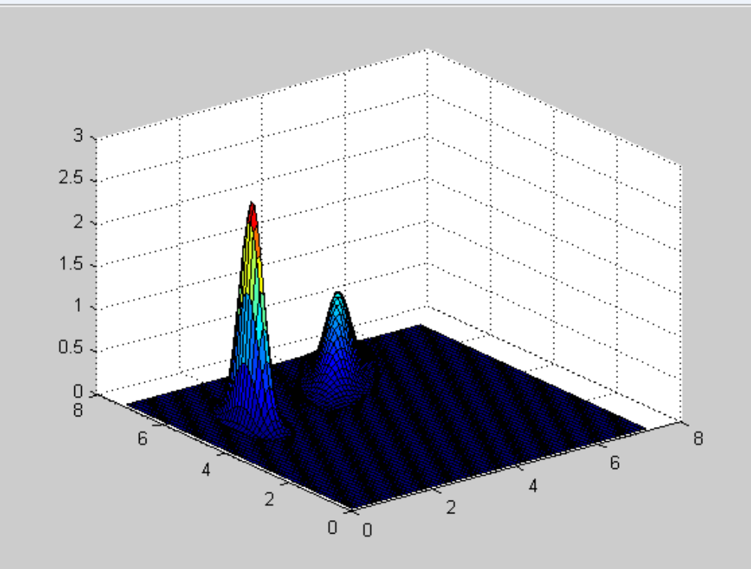
border functions g
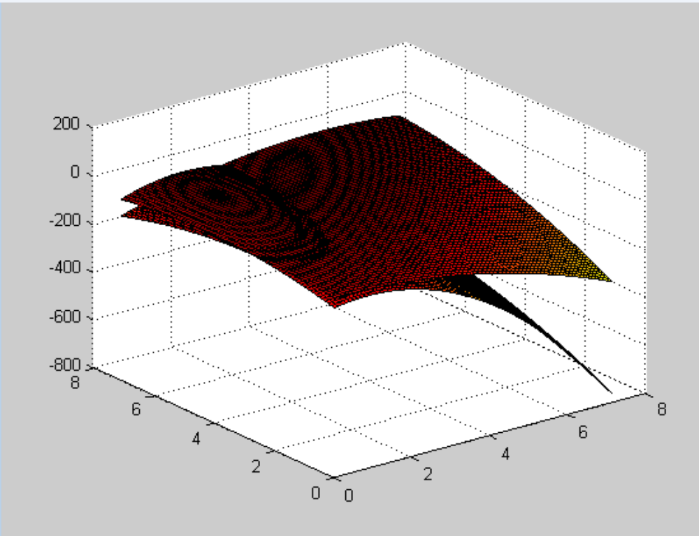

Features 1 and 4 (Petal length, Sepal width)
Gaussian
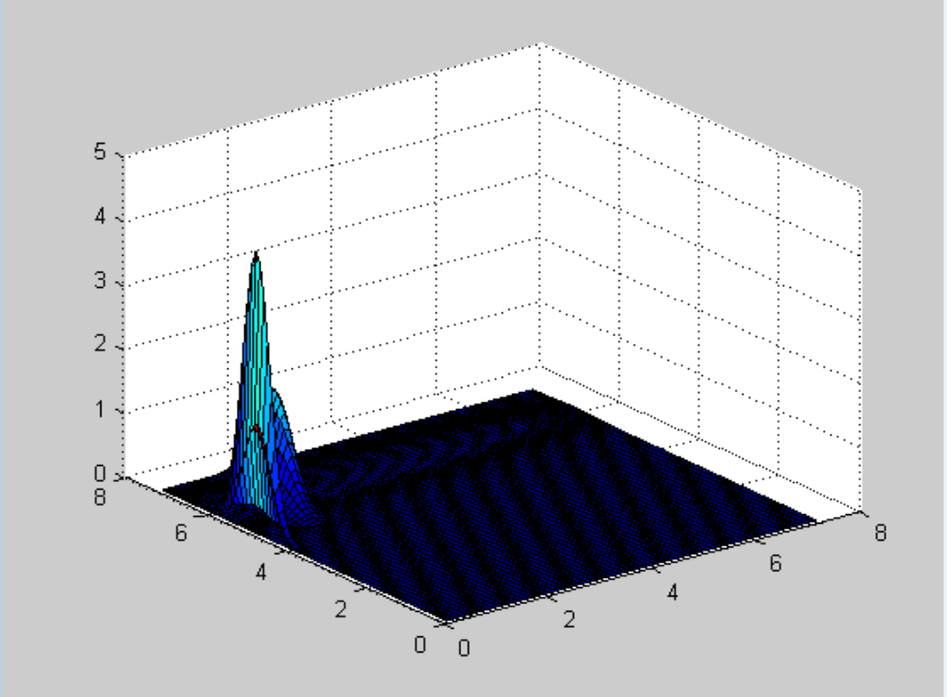
Border g functions
